State whether each of the following representations is a function.
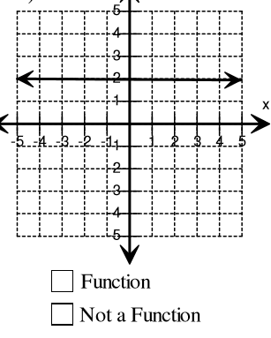 | 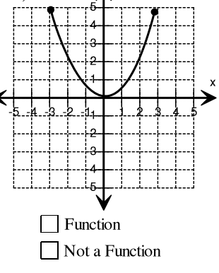 | 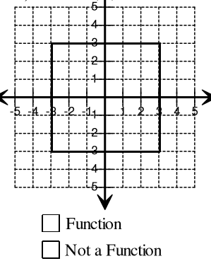
x y  2 6  3 10  4 2  5 6  6 10 | x y  1 6  3 10  1 6  3 10  2 19 | x y  1 6  0 3  4 7  5 -1  6 -8
f(1)=18  f(n) = f(n-1) + 6 | y = m(x - x₁) + y₁ | y=mx + b
For each sequence, complete the required information.
Sequence | Arithmetic or Geometric | Common Ratio or Common difference | Recursive Equation | Explicit Equation
-17, -11, -5, 1, 7…
13, 39, 117, 351…
88, 44, 22, 11…
21, 34, 47, 60…

Write an equation in point slope form for each of the given representations.
Representation | Equation in Point Slope form y = m(x – x₁) + y₁ | Equation in Slope Intercept Form y=mx + b
A line having a slope of 3 and passing through the point (5, -2)

x | f(x)
3 | 8
4 | 11
5 | 14
6 | 17

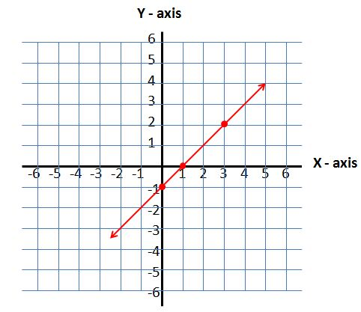
x | f(x)
-2 | 18
-1 | 10
0 | 2
1 | -6

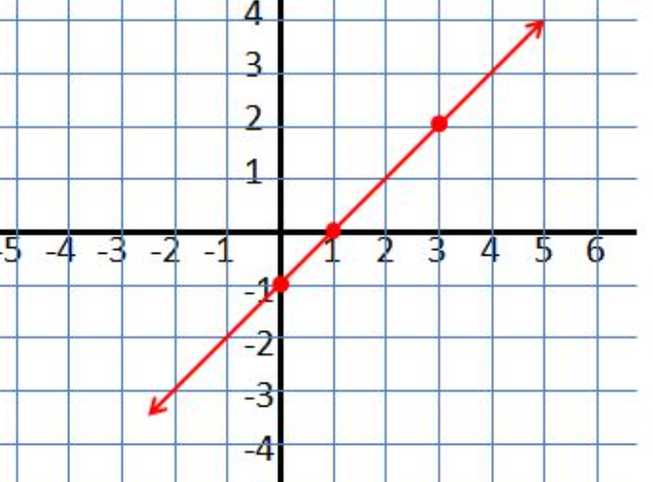
State the range of each function when the domain is given as D = {3,4,5,}
f(x) = 2x + 8 f(x) = 5^{x} f(x) = 3(2)^{x}

