Identify each as discrete or continuous.
Tickets to a concert cost $20 each.  Discrete or Continuous? | Save Mart sells bananas for $1.19 per pound.  Discrete or Continuous? | The volume of water in a swimming pool steadily decreases at a rate of 15 gallons per minute.  Discrete or Continuous?
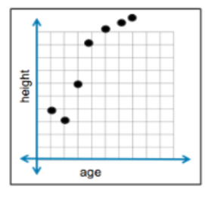 | 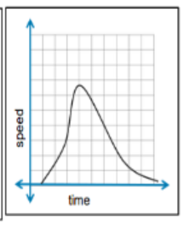 | 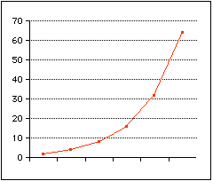
Identify each of the graphs as discrete or continuous.

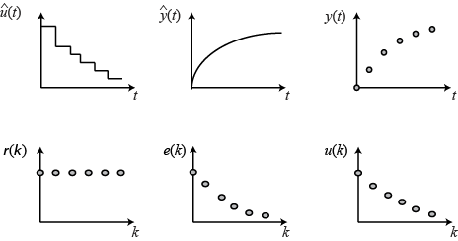

Write the missing part for each situation.
Verbal Description | Explicit Function | Recursive Function
The first term is 19 and you subtract 8 for each term.
 | f(n)=4(2)^{n-1}
f(1) = 100
f(n) = f(n-1)* ½
The fourth term is 56 and the pattern doubles with each step.
 | f(n) = 83 + 9(n – 1)
f(1) = -16
f(n) = f(n – 1) - 14

Write the equation for the function shown.
 | Linear or Exponential? | Equation for the function
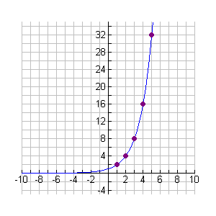
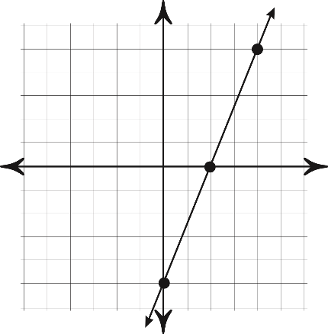
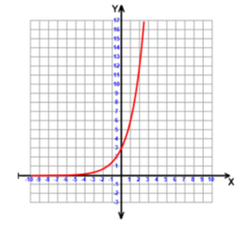
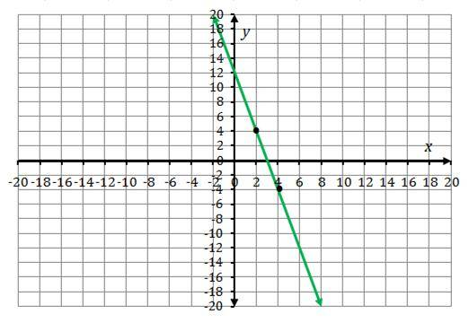

Write an equation to represent the situation:
You are saving money for a summer trip. You have $80 already saved, but plan to add $15 per week to your savings. Write an equation showing the amount of money, M, you have saved after w weeks.

