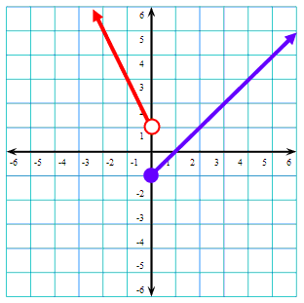
Identify the required information for the function.
- Maximum
- Minimum
- Increasing Interval
- Decreasing Interval
- Domain
- Range
- Constant Interval

For the above function, calculate the following:

f(1) =

f(-2) =

f(4) =

f(5) =

f(0) =

f(x) = -1

f(x) = 0

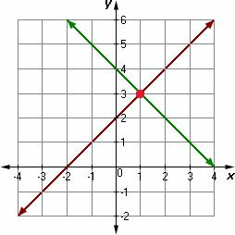
Find f(1)

Find g(1)

Find f(1) + g(1)

Find the x value where f(x) = g(x)
Find f(0) + g(0)
Find f(3) + g(3)
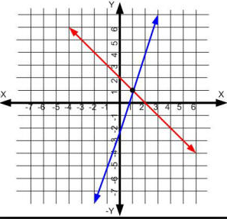
Find where g(x) = h(x)

Find f(2)

Find g(2)

Find f(2) + g(2)

Find where f(x) = 3

Find where g(x) = 3

Solve the literal equations:
u = 2x – 2 Solve for x.

g = ca Solve for a.

12am = 4 Solve for a.

$\frac{3x-y}{9}=z$ Solve for x.

