Name _______________________________ Date _______________ Period ____ Practice 4
Write three different explicit equations from the following table. Use caution when finding the common difference.
x | f(x)
3 | 19
5 | 25
7 | 31

Write three different equations in point-slope form from the following table. Use caution when finding the slope.
x | f(x)
3 | 19
5 | 25
7 | 31

Describe each pattern in words, then give the next three numbers in the sequence.
Sequence | Describe pattern In Words | Next three numbers
-10, -8, -6, -4…
2, -6, 18…
100, 50, 25…
12, 19, 26, 33…

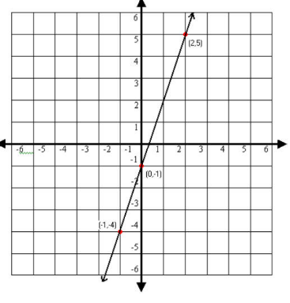
Write an equation for each graph in slope-intercept form.
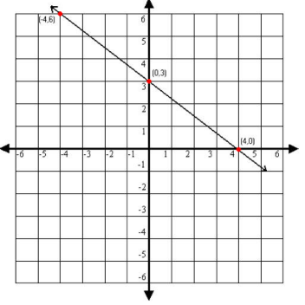
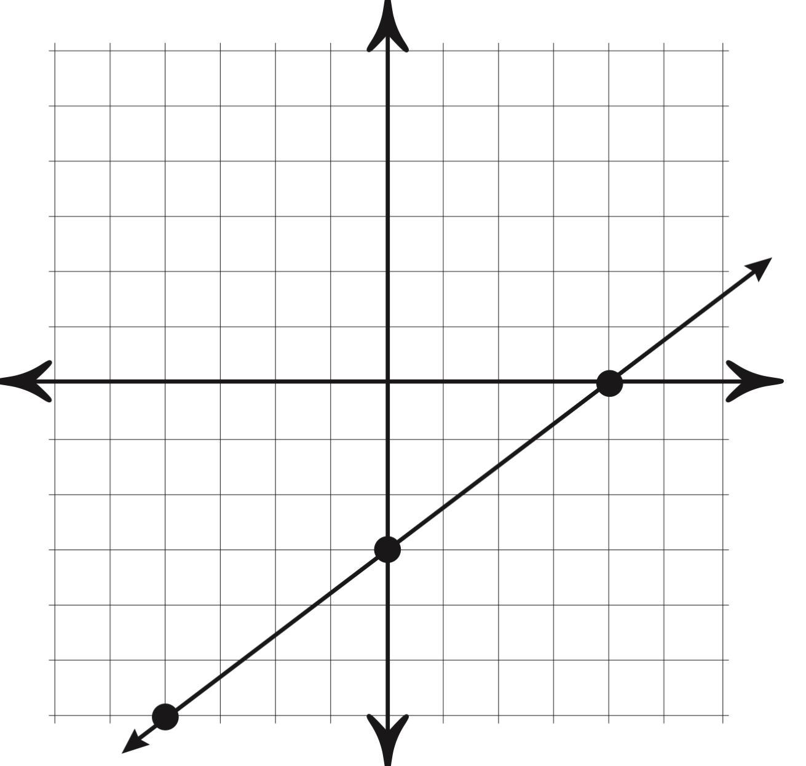

State whether each table is linear, exponential, or neither

x | f(x)
3 | 88
4 | 44
5 | 0
6 | -44

x | f(x)
3 | 2
4 | 7
5 | 12
6 | 17

x | f(x)
3 | 8
5 | 20
6 | 26
8 | 38

