Math II Study Guide 1
Name ______________________________________ Date __________________ Period ________
What type of transformation is shown in each figure?
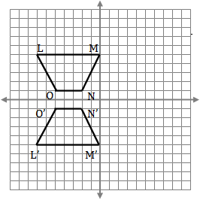  Type of Transformation? | 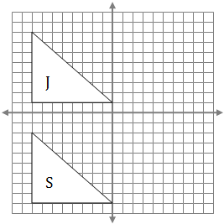  Type of transformation? | 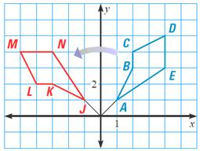  Type of transformation?

For each graph/figure shown, perform the required transformation.
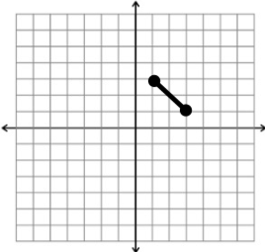  Rotate the line segment 90 degrees clockwise about the origin. | Rotate the line segment 180 degrees about the origin.
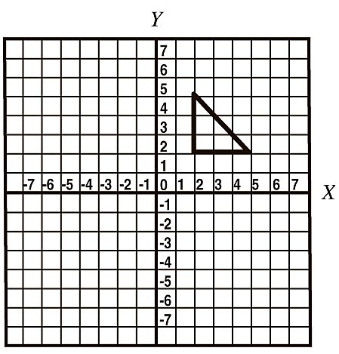  Translate the triangle according to the rule:  (x, y) (x + 3, y -5) | Reflect the triangle over the x axis
Reflect the triangle over the line y = -x. | 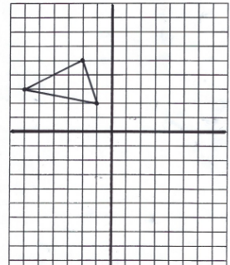  Reflect the triangle across the line y = x.
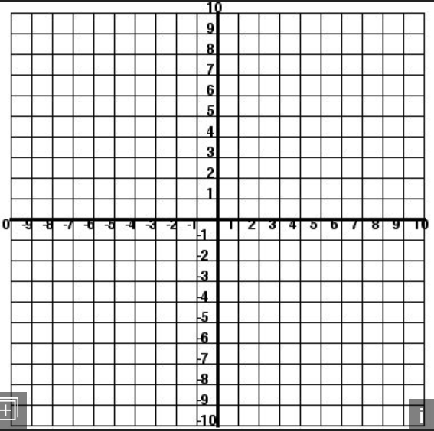
Graph the function on the coordinate plane.
k(x) = -½x – 7

Graph a line parallel to this line, but translate the line up 8 units. Label this line p(x).

Write the equation for p(x) in slope-intercept form.

Graph the function on the coordinate plane.
g(h) = 3x + 8

Graph a line perpendicular to this line anywhere on the coordinate plane

Write the equation for your line.

