Name _______________________________________ Date ___________________ Period ________

Study Guide 2

Using the Distance Formula – Find the distance between the points in each situation:

|  |  |
| --- | --- |
| Points:  (4,8) and (9,21) |  |
| Points:  (-4, 7) and (-9, -1) |  |
|  |  |
|  |  |

If f(x) = g(x) + 2, then find the translation equation for f(x) for each of the following **unique** situations:

a) g(x) = 3x + 4

b) g(x) = 2x2 + 4x – 10

c) g(x) = 4(3)x – 8

Simplify each of the following situations:

f(x) = g(x) + 3 and g(x) = x + 4

Find f(3)

f(x) = g(x) + 3 and g(x) = -x + 25

Find f(3)

f(x) = g(x) + 3 and g(x) = 7x – 2

Find f(3)

f(x) = g(x) + 3 and g(x) = 4(2)x

Find f(3)

Which of the following sequences could be generated by a quadratic function?

a) {1, 2, 3, 4, …} b) {-5, -3, 3, 13, …}

c) {2, 4, 8, 12, …} d) {2, 6, 18, 54, …}

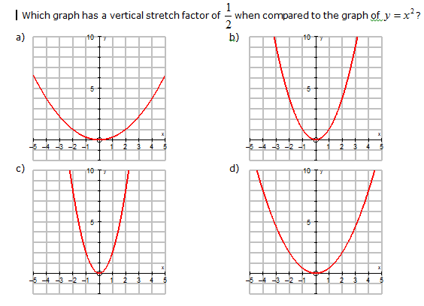

For the function , the y-intercept is **always**:

a)  b) c c)  d) 

The function is represented by the following graph. Which of the following statements is true?

1. a>0 and c> 0
2. a>0 and c<0
3. a<0 and c<0
4. a<0 and c>0