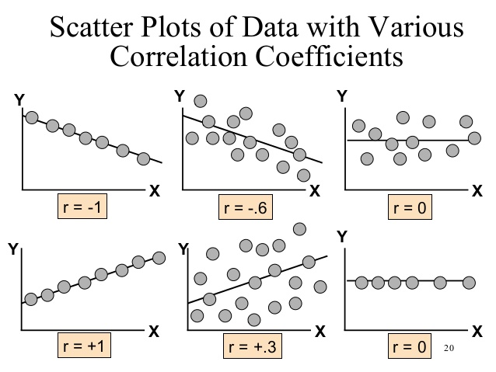
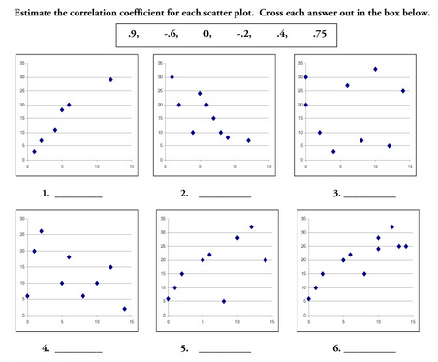
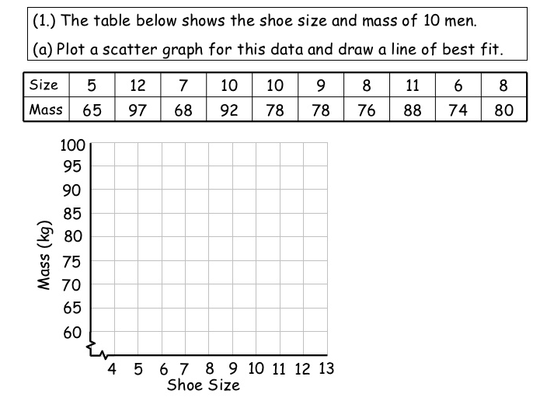
What type of correlation is shown in the above scatter plot?
Draw a line of best fit.
Write the equation for the line of best fit you have drawn.
Use linear regression in desmos to find a precise equation for a line of best fit.
Estimate the mass of a man with a shoe size of 9.5.

Matching
Match each of the following simplified expressions on the left with it’s matching factored expression on the right.
11.______

12.______

13.______

14.______

15.______

11. $x$ | a. $\left(3x+7\right)+(4x-9)$
12. $x^{2}-9$ | b. $(x-3)(x+3)$
13. $7x-2$ | c. $(2x-5)(x+5)$
14. $12x^{2}-20x-8$ | d. $4(x-2)(3x+1)$
15. $2x^{2}+5x-25$ | e. $\left(8x-9\right)-(7x-9)$

Given each function, evaluate for the value of x.
f(x) = 3x² + 2x – 8 g(x) = -2x² – 6x + 1
f(4)= g(-3) =

Determine whether each recursive function is linear, exponential, or

